Two Missile Dreams
August 12th, 2024

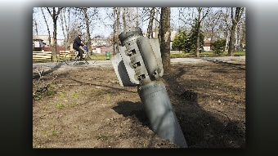
Mother Clare began, the Lord bless and keep you precious family. I want to give you an update on the situation in the Middle East. Ezekiel had two concerning dreams. One was of a large missile lying on the ground in the desert. Several military and scientific men were examining it and continually walking around it, scratching their heads and questioning why it did not reach its target or detonate.

The next dream he had was of President Trump standing before a huge crowd with one hand in his pocket, and he was speaking to them. Behind him was a missile that was crumpled up on the ground. It seemed as though an Angel had intercepted it like a soda can and crushed it into the ground.

Both these dreams remind me of the Ezekiel 38 war, where Israel’s enemies surrounded her, but God sent His Angels to disarm every single bomb, so that no harm came to them.

My dear family, KEEP PRAYING!!! Your prayers are working wonders! The Lord is Mighty indeed! He hears the cries of His people and will save us with His Mighty arm.

Amen!

